+
Type or print legibly and return to:
15th Annual BIB, 132 North Broadway, Albert Lea, MN 56007
August 20, 2022

Head Cook _______________________________________________________________________

Mailing Address ___________________________________________________________________

City, State, Zip_____________________________________________________________________

Cell ( ) ____________________________

E-Mail ___________________________________________________________________________

Cook-Off Categories Check all you wish to enter
Entry Fee: CHECKS ONLY PAYABLE TO: BIG ISLAND BBQ

_____ One SCA steak $160.00 sign up on web site www.steakcookoffs.com

_____ Both SCA steaks $320.00 sign up on web site www.steakcookoffs.com

Also: BIB Page #2 signed waiver form

Mail to: 15th Annual BIB, 132 North Broadway, Albert Lea, MN 56007

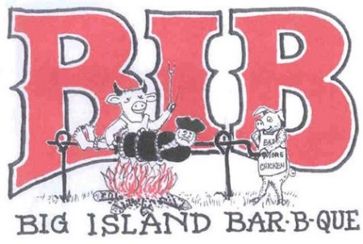

WAIVER OF LIABILITY: (Must be signed to enter) In consideration for the BIB Committee accepting this entry, I, the undersigned, intending to be legally bound, hereby, for myself, my heirs, executors, and administrators, waive and release any and all rights and claims for damages I may have against the Big Island Rendezvous and Festival, Inc. and the City of Albert Lea and the committee, their agents, successors, and assigns for any and all injuries suffered by me or my team in this event. Further, I hereby grant full permission to Big Island Rendezvous and Festival, Inc. or their authorized agents to use any photographs, videotapes, recordings or any other record including digital and internet on this event for any legitimate pose. I agree to abide by all contest rules set out by the Big Island Barbeque and SCA. THERE WILL BE NO REFUNDS.

Signature _______________________________________________ Date ____________

Printed Name _________________________________________
ADDITIONAL NOTES
In the following box, please give a description of what you will be bringing to your site. Include all motor homes, RVs, campers, trailer cookers, tents, etc. If you would like to set up next to a particular team or have any other special needs, please state this in your comments below. Although we cannot guarantee placement, we will make every effort to accommodate your needs.

NO ELECTRICITY, WATER HOOKUP OR ICE ON SITE

NO OVERNIGHT CAMPING

Who should the checks be made payable to (if different from your team’s name)?

.

Dear Cook:
After having last year’s contest at this new site, we hope you might want to attend this year’s special 15th Annual State Steak Cookoff Association (SCA) DOUBLE contest ON Saturday. This event will be in Albert Lea, Minnesota. There is NO WATER, ICE, HOOK-UPS or POWER or OVERNIGHT CAMPING.

SCA DOUBLE event is judged by SCA judges. SCA Steak grand champion qualifies for the SCA World Steak Competition in Fort Worth, TX. It pays ten places for steak: $1,000 for 1st, $400 for 2nd, $300 for 3rd, $200 for 4th, $150 for 5th and $50 for 6th through

If you have any questions or would like additional registration forms, please call me or email me.
Thank you again for considering joining us for the 15th Annual Big Island Barbeque in Albert Lea, Minnesota on August 20, 2022, at the City Arena, 701 Lake Chapeau Drive, Albert Lea, Minnesota,

Yours in BBQ,
Perry Vining, Founder/Coordinator
Cell phone # 507.402.6371
email: pvining@smig.net http://bigislandfestivalandbbq.org

TIMES |  | 8:00AM- 10:00AM |  | 10:00 AM | 11:00 AM | 12:00 PM |  | 1:00-1:30 PM |  | 3;00-3:30 PM |  | 5:00 PM
SCA | SATURDAY AUGUST 21, 2021 | Check in at City Arena |  | COOKS MEETING & Selection  Steaks A | Steak B Selection | SCA JUDGE MEETING City Arena |  | SCA STEAK A TURN-IN |  | SCA STEAK B TURN-IN |  | SCA AWARDS CEREMONY

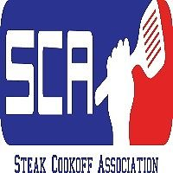

SCA-Big Island Steak Cookoff

Saturday, August 20, 2022, Big Island Steak Cookoff at Big Island BBQ. Contest benefits Kid’s Scholarships for Big Island Rendezvous. Cook and judge registration is thru Steak Cookoff Association web site www.steakcookoffs.com

Steak Payout FOR EACH CONTEST 1st – $1,000 2nd – $400 3rd – $300 4th – $200 5th – $150 6th-10th -$50
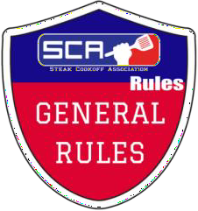

- Cooks may be cook on any fire or heat source. (Wood, Charcoal, Gas, Electric, Pellet, Sous Vide etc.)
- SCA events are judged by a panel of judges and will be in a “blind judging” format.
- Each team is encouraged to have some type of fire extinguishing device in their cook site.
- The cookoff promoter/organizer will provide all competition steaks for the event in order to create a level playing field. No other ribeye steaks are allowed at a team’s cook site. Teams are subject to random ice chest inspections by any SCA Representative.
- The SCA standard for steaks is a minimum of 1 1/8” or 3cm thick, boneless, choice, ribeye steak.
- Teams are subject to random ice chest inspections by any SCA Representative.
- Turn in times will be announced at cooks’ meeting, and will not be changed once announced.
- Cooks may not register for overlapping events in different cities on the same day. Teams must sign the turn in ticket at the time of turn in.
- The spouse of an SCA Rep is not allowed to cook in any event that his or her spouse is officiating.
- Grills may be used by more than one cook. Each registrant must cook their own steaks and may only turn in one steak per competition. Cooking steaks for another registrant in the same competition will result in a disqualification.
- SCA Kids competitors are 4-15 years of age. The parents may start the fire, but the KIDS must do the seasoning and cooking.
- SCA head cooks must be at least 13 years old to compete in the Adult categories. They would do their own steak selection, seasoning, cooking, steak turn at the event and could not compete in the kid’s category at the same event.
- SCA Certified Judges must have completed an SCA Certified Judges Class and be an SCA member in good standing.
- In case of a final results tie, the prize money will be split between the teams. Example: a total tie between two teams for first place. The prize money from first and second place will be added up and divided between the cookers. The rep will flip a coin to decide who gets which trophy.
- In case of a total tie score (score is tied in all categories) the prize money will be split between the cooks. Example: A total tie between two teams for first place. The prize money from first and second place will be added up and divided between the cookers. The rep will flip a coin to decide who gets which trophy. If the tie is for first place both cooks would be offered an A Golden Ticket. If one of them is previously qualified the second ticket may not be passed down. If both are qualified, only one ticket will be passed down.
- If there is a total results tie in the top ten, both teams will be awarded the same points.
- If a number is called and no one claims the award within one hour after awards, the prize will go unclaimed. The final results will not be affected, and SCA Points will remain the same.
- The head cook must be a member of SCA by the end of the cooks’ meeting in order to be eligible for any added money at events.
- Ribs can be either baby back or spare ribs unless specified by the promoter and posted on the flier.
- The winner of every SCA-sanctioned event will be invited to the SCA World Championship. If the winner of the event is not a member at the time of the win, he/she will have until the following Monday at 8am CST to become a member. If the cook does not become a member, the invitation will roll down to the highest placing member (no lower than 10th place). If there are no teams eligible for the invite, then the invite will become an “At Large Bid”.
- All decisions by SCA Reps at an event are final.

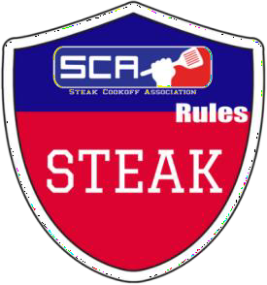
- Steak may be cooked on any fire or heat source. (Wood, Charcoal, Gas, Electric, Pellet, Sous Vide etc.)
- Steak cooks may only register once per competition and must cook their own steaks.
- No other ribeye steaks other than the ones provided to the teams by the promoters are to be present at cook sites.
- Steaks may be lightly trimmed before, but not after cooking.
- Steaks may not be marked or branded in any way. (Grill marks are not considered marking).
- Turn in one steak, whole and uncut, on top of the provided foil disk. The provided foil disks must be placed in the box, silver side up, and not folded in any way. The steaks will be judged as presented in the box.
- No sauce or garnish is allowed in the steak turn in box. A compound butter is allowed, as long as it is melted on the steak.
- Placement of the steak and inspection for foreign objects is the team’s duty, the boxes will not be opened at the turn in table.
- There are no size standards for the seasonings on the steak.
- Pooling of NATURAL juices in the box is acceptable.
- Steaks are judged on Appearance, Doneness (Medium), Taste, Texture and Overall Impression.
- Tie breaker: Taste, Doneness, Texture, Appearance, and Overall Impression.

REASONS FOR A STEAK DQ
  - Any foreign object found in the turn in box. (String, Toothpick, Skewer, etc.)
  - A steak turned in after the turn in window has expired.
  - Using ribeye steaks other than the ones provided by the promoter.
  - Any of the above rule violations

